**Name-Ujjawal Mandhani**

**Batch-F6**

**Enroll No.-9918103237**

**COA Lab Test**

**Question 1:**

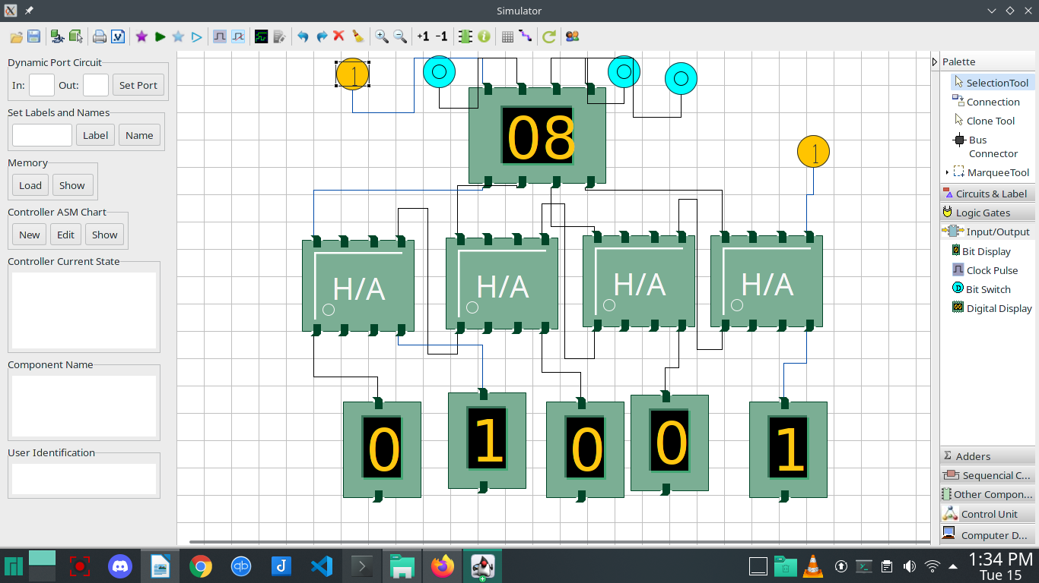

**Question 2:**

MVI C,05

LXI H,3000

LXI D,3500

MOV A,M

STAX D

INX H

INX D

JNZ 2008

HLT

